# Relational Algebra Queries

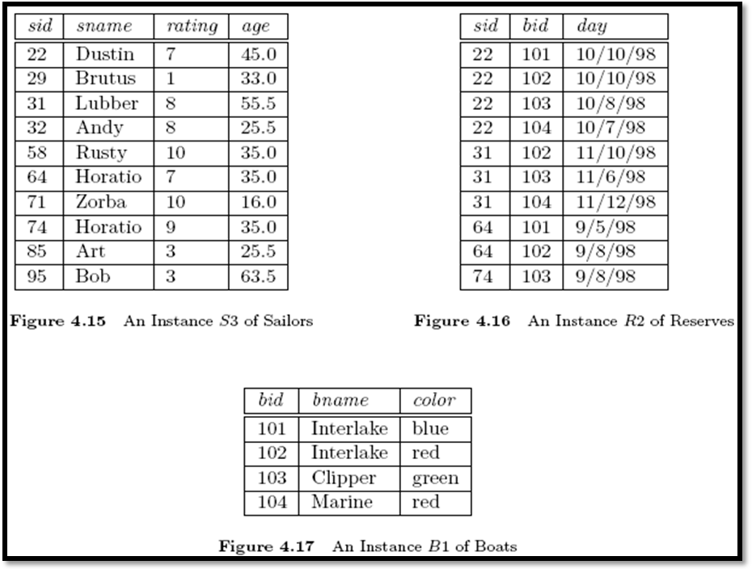

create table Sailors(

sid int not null constraint sailors_pk primary key,

sname varchar2(20),

rating int,

age decimal(4,1)

);

create table Boats(

bid int not null constraint boat_pk primary key,

bname varchar2(20),

color varchar2(20)

);

create table Reserves(

sid int,

bid int,

day date,

primary key (sid,bid,day),

foreign key (sid) references Sailors(sid),

foreign key (bid) references Boats(bid));

(Q1) Find the names of sailors who have reserved boat 103

# SQL> select s.sname from sailor s, reserve r where s.sid=r.sid and r.bid=103;

(Q2) Find the names of sailors who have reserved a red boat

SQL> select s.sname from sailor s where s.sid in(select r.sid from reserve r where r.bid in(select b.bid from boat b where b.color='red'));

(Q3) Find the colors of boats reserved by Lubber

SQL>SELECT DISTINCT b.color FROM boat b, reserve r, sailor s WHERE s.sname = 'lubber' AND s.sid = r.sid AND r.bid = b.bid;

(Q4) Find the names of sailors who have reserved at least one boat

SQL> Select distinct s.sname from sailor s, reserve r where s.sid=r.sid;

(Q5) Find the names of sailors who have reserved a red or a green boat

SQL>select s.sname from sailor s,boat b, reserve r where r.bid=b.bid and b.color='red'

union

select s2.sname from sailor s2, boat b2, reserve r2 where r2.bid=b2.bid and b2.color='green';

(Q6) Find the sids of sailors with age over 20 who have not reserved a red boat

# SQL> select s.sid,s.sname

**from sailors s,boats b,reserves r**

# where s.sid=r.sid and b.bid=r.bid and s.age>20 and b.color!='red';

(Q7) Find the names of sailors who have reserved all boats

SQL> select s.sname from sailor s where

not exists (select b.bid from boat b where not exists (select r.bid from reserve r

where r.bid=b.bid and r.sid=s.sid));

(Q8) Find the names of sailors who have reserved all boats called Interlake

SQL> select * from sailor

where sid in(select sid from reserve inner join boat on reserve.bid=boat.bid where boat.bname='interlake')

1. ***Count the number of different sailor names.***

SQL> SELECT COUNT( DISTINCT S.sname ) FROM Sailor S;

1. ***Calculate the average age of sailors.***

SELECT COUNT( DISTINCT S.sname ) FROM Sailor S;

1. ***Find the name and the age of the youngest sailor.***

SELECT S.sname, S.age FROM Sailors S WHERE S.age = (SELECT MIN(S2.age) FROM Sailors S2 );

Find the average age of sailors for each rating level.

SELECT S.rating, AVG(S.age) FROM Sailors S GROUP BY S.rating;

1. ***Find the average age of sailors for each rating level that has at least two sailors.***

SELECT S.rating, AVG(S.age) AS avg_age FROM Sailors S GROUP BY S.rating HAVING COUNT(*) > 1;

1. ***Find the names of sailors who have reserved a red boat, and list in the order of age.***

SELECT S.sname, S.age FROM Sailors S, Reserves R, Boats B WHERE S.sid = R.sid AND R.bid = B.bid AND B.color = ‘red’ ORDER BY S.age;

1. ***Find the ids and names of sailors who have reserved two different boats on the same day.***

SQL> SELECT DISTINCT S.sid, S.sname FROM Sailors S, Reserves R1, Reserves R2 WHERE S.sid = R1.sid AND S.sid = R2.sid AND R1.day = R2.day AND R1.bid <> R2.bid;

OR

SQL> SELECT DISTINCT S.sid, S.sname FROM Sailors S, Reserves R1, Reserves R2 WHERE S.sid = R1.sid AND S.sid = R2.sid AND R1.day = R2.day AND R1.bid != R2.bid;

1. ***Find the sailor id’s of sailors whose rating is better than some sailor called Bob***

SQL> select s1.sid from sailor s1,sailor s2 where s1.rating>s2.rating and s2.sname='bob';